MultiLingual Task Manager – MVP Specifications

* Architecture
* Web Architecture 101

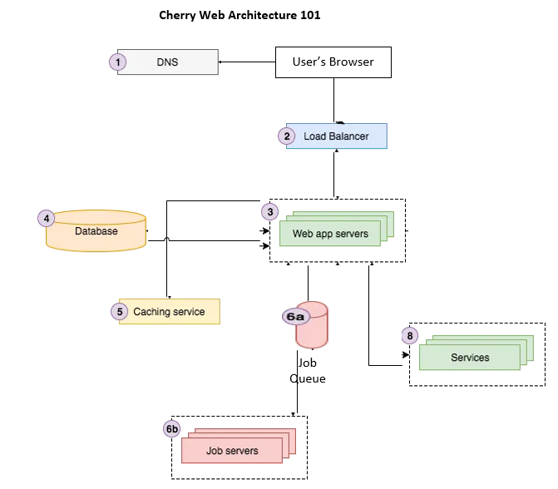

* Web Application Architecture

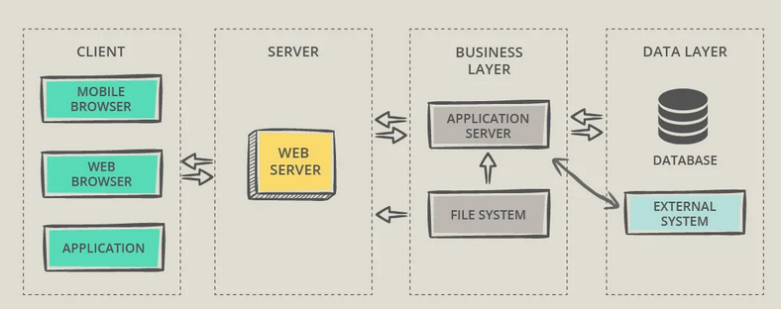

The project’s approach is a react Java-based web application architecture with identical frontend technological components that simplify the work of developers. They can manage user’s frontend services as well as backend ones. This web application architecture patterns supply code sharing and reusability, uncomplicated knowledge-exchange that guaranty consistency and a variety in the available tools. These advantages provide flexibility and reliability at the same time. Shortly, react framework was created with the assimilation of mind, that’s why a lot of companies use it to incorporate different services using a standardized user interface, which also gives the brand recognition as one of the advantages. React Web Application Architecture is a great option to develop user-friendly and robust cloud software that could integrate with other cloud based real-time databases like firebase, used in this context.

* APIs

The system has two layers of the interface such that one is secure and the other is not. The non-secured interface displays a welcome page that introduces the user to the platform with instructions on how to navigate to the secured interface, which is the core part of it. The user is allowed to authenticate with any valid google mail account only before they can have access to the secured interface of this system. This authentication process was achieved through the google cloud API as a third party service.

The secured interface, allows the user to view dashboard displaying existing data records retrieved from the firebase real-time database. This also allows them to add new data to the database, modify existing data in the database, or delete existing data that are not needed anymore. Finally, the database secured access was achieved through the google firebase API which is also a third party services.

* Data Modelling

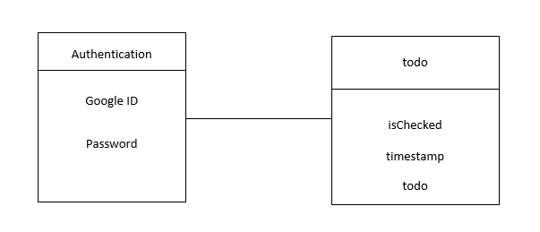

* User Stories

3-5 detailed user stories that will be satisfied when my MVP is complete are;

* MVP has a simplified interface “fast content loading”
* MVP is optimized to adapt to all device interfaces “responsive”
* MVP is user friendly
* MVP is unique for being multi-lingual
* MVP is robust
* Mockups

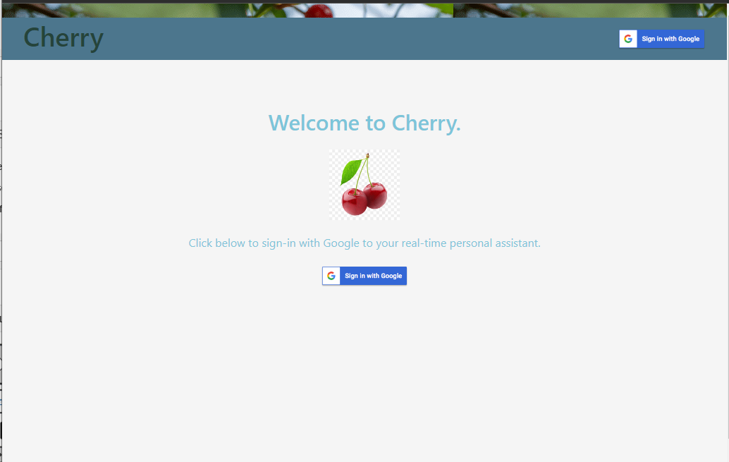

Welcome / Landing non-secured page

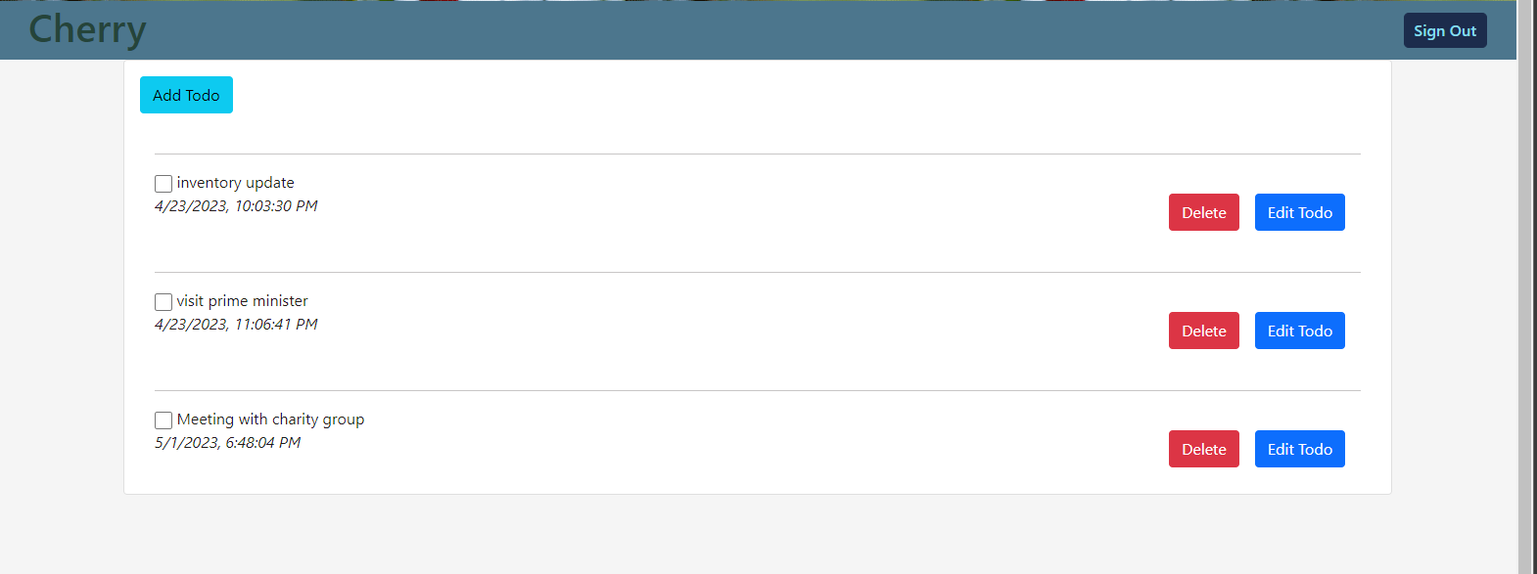

Home - secured dashboard

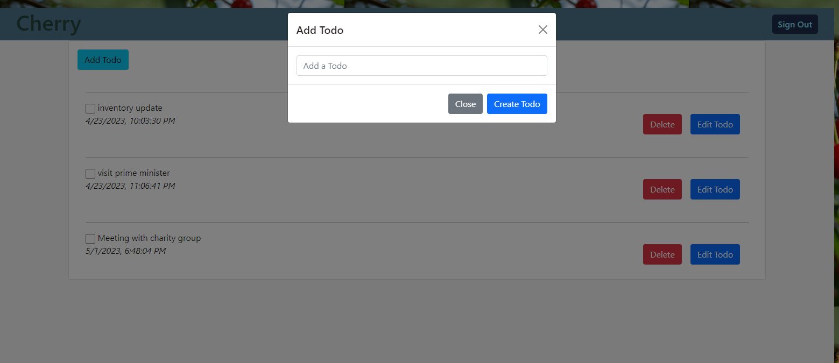

Modal Interface to add new records

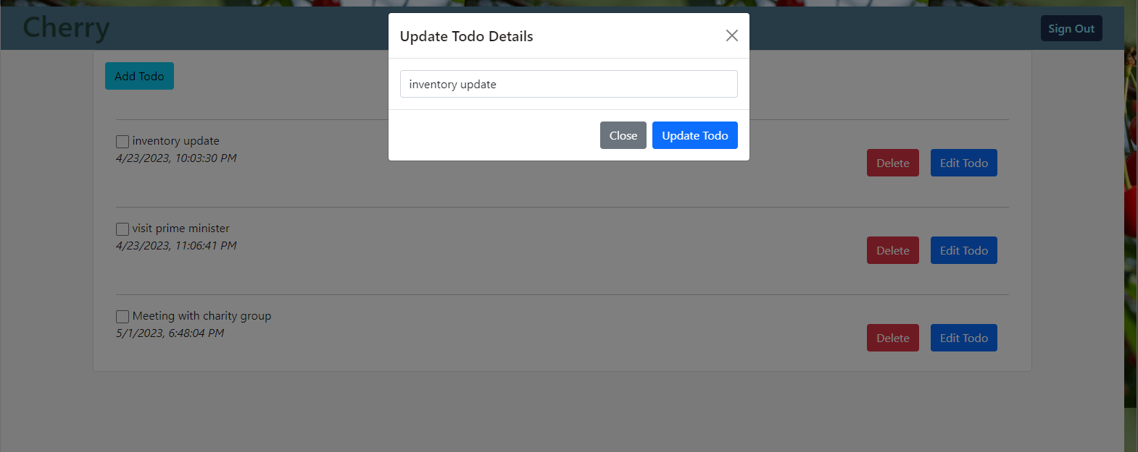

Modal interface to edit existing record

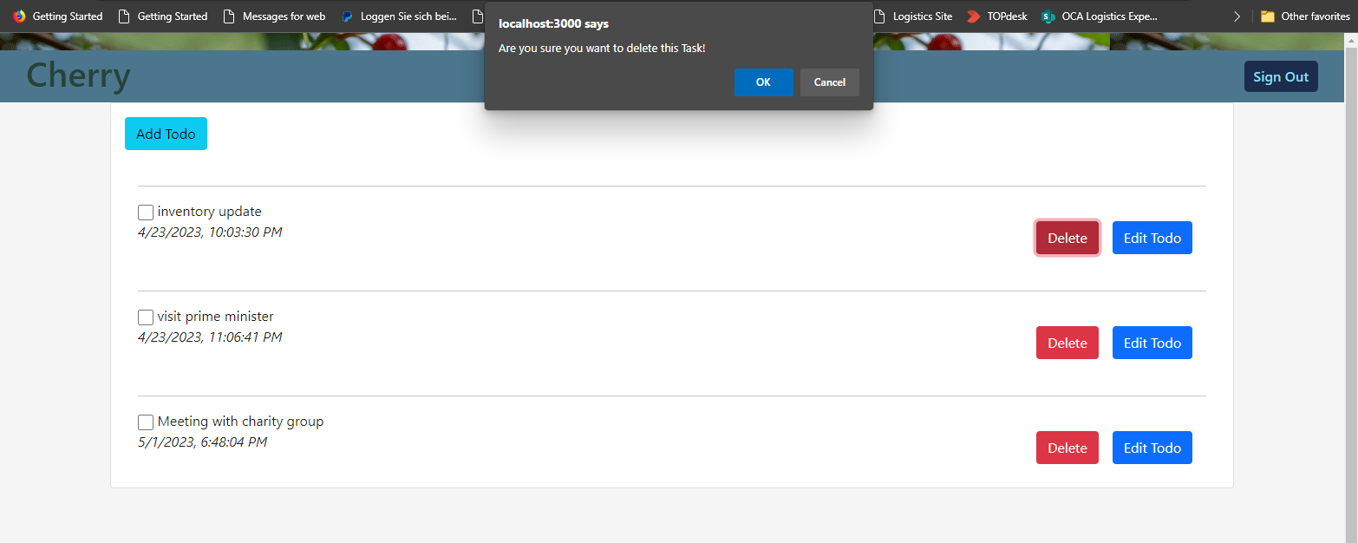

Boolean interface for deleting records